STANDARD FORMAT OF “LEHENGA DESCRIPTION”


For Online Selling Products
Design Name: MANNAT-B
Product Colours NO.: B2

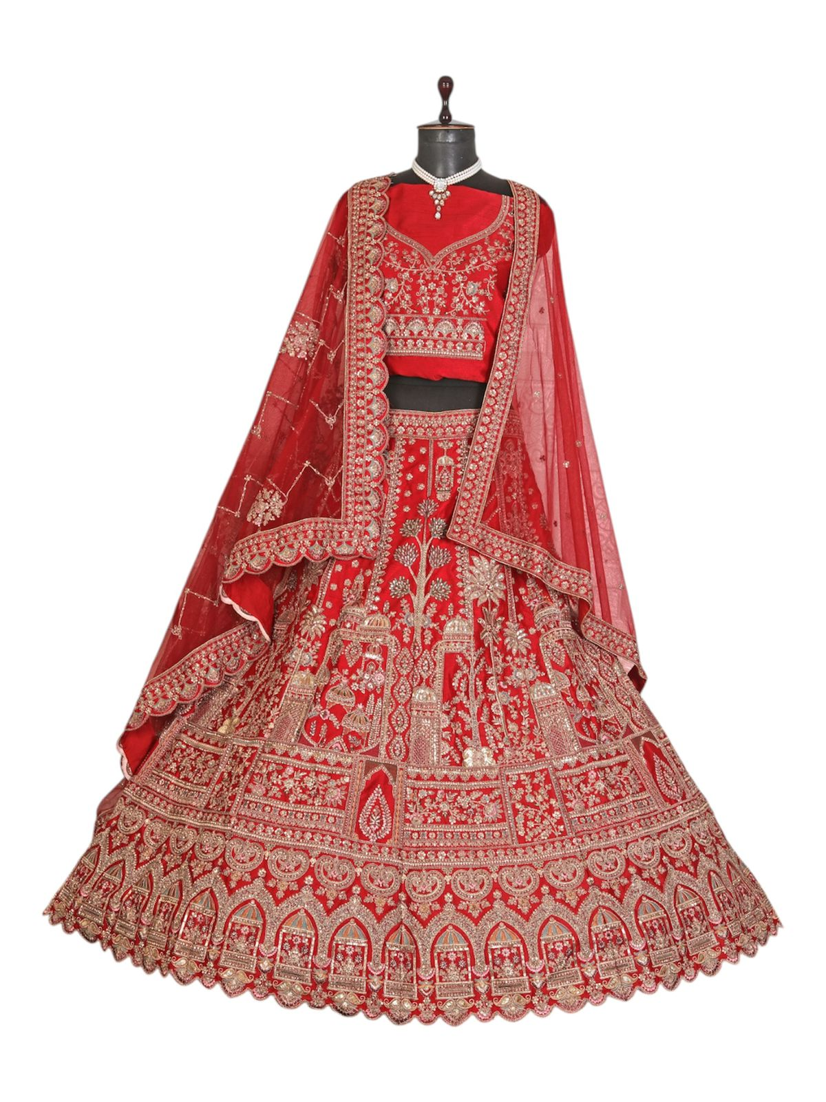
Particulars | Details
Lehenga Fabric | Italian Silk
Blouse Fabric | Italian Silk
Dupatta Fabric | - Net Dupatta &  - Net Dupatta
Work Type | Heavy Zari
Colour | Bridal Red
Pattern | Bridal Designer
Stitching Type | Semi-Stitched (Can be customized up to 44")
Occasion | Wedding
Fit Type | Regular Fit
Care Instructions | Dry Clean Only
Package Contents | 1 Lehenga, 1 Blouse Piece, 2 Dupatta

KEY HIGHLIGHTS
- Crafted from premium Italian Silk fabric for a smooth texture and elegant drape
- Adorned with classic zari work that enhances the traditional bridal look
- Comes with a double dupatta set, including a graceful net dupatta
- Designed in a Bridal pattern, perfect for weddings and grand ceremonies
- Semi-stitched design allows easy customization up to size 44
- Regular fit ensures comfort while maintaining a graceful silhouette
- Ideal for weddings, bridal wear, and special festive occasions
- Recommended dry clean only to preserve fabric quality and work detailing

